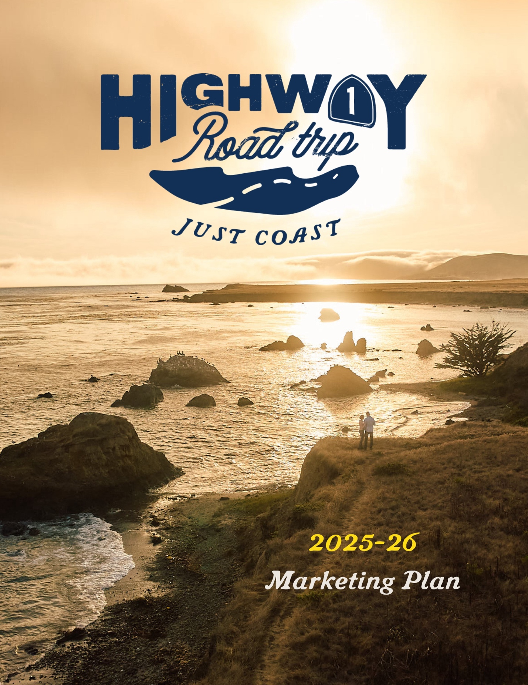

Executive Summary
During the 2024-25 fiscal year, the unincorporated San Luis Obispo County Tourism Business Improvement District (CBID), known as Highway 1 Road Trip, continued to successfully navigate the rapidly changing travel landscape. Although a myriad of challenges continues to affect travel in our region - including ongoing economic pressures and the closure of Highway 1 - we will forge ahead to focus on increasing awareness and offering travel planning resources driving high levels of intent to visit. Utilizing the resources of our focused and flexible team, we anticipate another successful year of continuous improvement along with several key new initiatives designed to take us to the next level in promoting memorable visitor experiences while being stewards for thriving, welcoming, and cohesive communities.

Year End Synopsis
After more than two years of consistent year-over-year gains after the pandemic, San Luis Obispo County experienced softness in 2024 and early 2025, possibly due to having tapped the pent-up demand from the peak pandemic years. As the phenomenon of “revenge travel” waned, the fear of an economic downturn and a rise in inflation led to more conservative travel behaviors, particularly among lower-income groups. Overall travel frequency declined throughout California and at the same time higher income groups are traveling more internationally. Visit California reported that a full third (34%) of U.S. travelers are saying travel is too expensive. And along Highway 1 in San Luis Obispo County, the northern communities are still struggling with the closure of the highway to the north.
However, travelers say they are excited about future travel, with 90% of California travel consumers saying they have one or more leisure trips planned in the next 12 months. And even with a downturn in international travel, there’s optimism for SLO CAL with a potential increase in domestic travel.
In the past year, marketing efforts drove more visitors to the website, more efficiently with website statistics showing an increase in both visitation and engagement by nearly 10 percent over prior year. A survey of our growing database showed that 92 percent of those who downloaded a map were using it to plan a trip. We launched a new brand, “Just Coast,” that helped us drive increased awareness; created important content, including a Highway 1 road conditions page that quickly vaulted into one of the top traffic pages; and continued to grow our first party data, important for engaging with interested travelers through all channels.

Highway 1 Road Trip has seen success in engaging with the audience through storytelling and content that highlights the unique experiences along our stretch. Utilizing paid media, email marketing, social media, content marketing/blog posts, and user-generated content to share the beauty and adventure of Highway 1, along with our new “Just Coast” branding, our story has resonated well with both new and returning travelers.

- Year-over-year organic traffic to the website was up again.
- Our database is at an all-time high and continuing to grow.
- Refinements in targeting and refreshed branding allowed us to spend less and get more.
- We engaged more fully with video in paid media driving strong volume and click thru rates. YouTube brand lift study showed solid gains in awareness and consideration.
- Continued to integrate Travel for Good messaging throughout our marketing efforts, with more published articles including Stewardship Travel for Good tips in the story.
- All metrics in social media were up over prior year as we created a new strategy and increased collaboration with Visit SLO CAL and other communities.
The organization remains viable and collaborative. Furthermore, our local fund area boards continue to thrive funding hundreds of projects over the last 12 years, all guided by 29 volunteer board members, 4 administrators and 5 marketing teams.
We also continue to improve our cooperative program offerings and partnership with our seven local fund area boards, seek new opportunities, and bolster our 10+-year-old Stewardship Travel for Good efforts as sustainability continues to be an important platform in tourism. We look forward to continued and smart growth in visitation for Highway 1 communities.

For the third consecutive year, we hit over 1M+ in all disciplines.
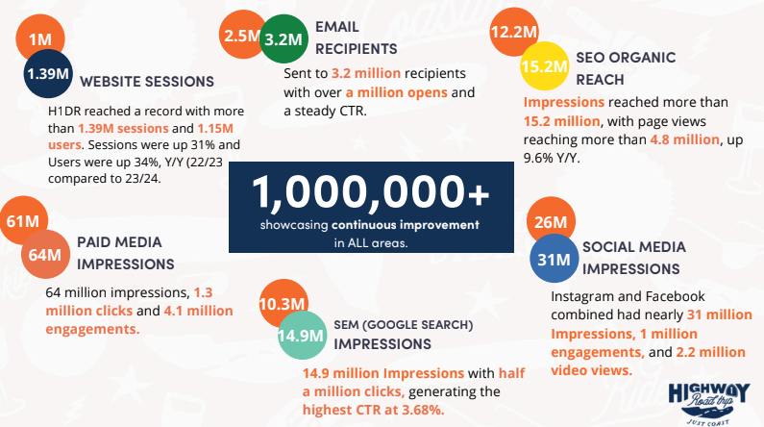

Public Relations efforts resulted in top tier placements
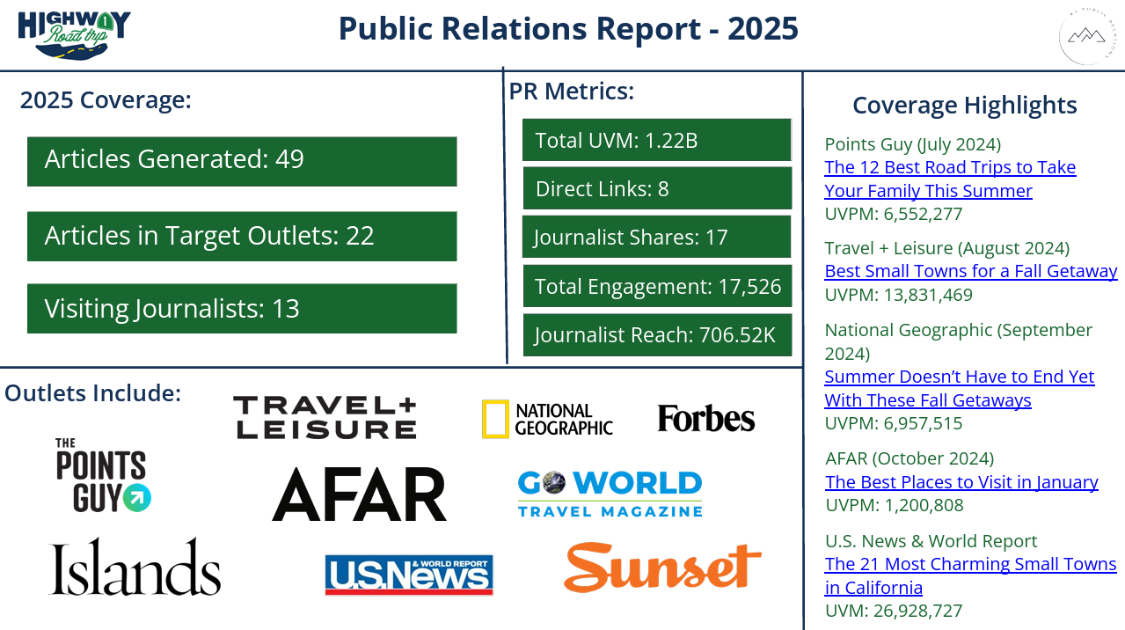

In May 2025, the CBID Board, in conjunction with SLO County and Civitas Advisors formed a new 501(c)(6) nonprofit corporation, Highway 1 Tourism Alliance (H1TA), to guide H1TA as it becomes the designated county contractor for the San Luis Obispo County Tourism Business Improvement District (SLOCTBID). This process includes forming the corporation and receiving tax-exempt status, creating new corporation bylaws, finalizing the agreement between San Luis Obispo County and H1TA for H1TA to receive assessment funds and carry out the SLOCTBID programs for both the regional effort and the local fund area efforts.
Looking Ahead – Tourism Economics Forecast
Visit SLO CAL contracted with Tourism Economics in the fall of 2024 to provide a forecast for 2025. While some of their forecast has since been softened, below are the key trends they anticipated:
- Hotel room revenue is expected to grow 2.1% in 2025 and 2.9% in 2026.
- Tax policy assumptions support a higher level of real GDP through the end of the decade, though the negative macroeconomic consequences of higher tariffs and immigration restrictions still predominate in the out-years.
- The US economy is doing well. The savings rate, real disposable income growth, and corporate profit margins have all been recently revised upward. These revisions plus the results of the recent election suggest consumer spending will strengthen next year.
- Forecast is for solid growth in consumer spending over the next few years, but that is largely attributed to the resilience of high-income households, who account for most of the consumption. By contrast, spending patterns of low-income households will take many years to recover. The share of low-income household spending on discretionary items fell sharply in 2020 and has barely begun to recover, a clear sign that more of their incomes are going toward necessities.

Looking Ahead to 2025 – Visit California Travel Trends
Visit California highlighted several emerging travel trends that will shape visitor expectations in the coming year. Economic uncertainty, inflation and rising travel costs are impacting consumer spending, but travel remains a priority for many. This has led to a rise in road trips, which continue to be a favored mode of travel.
Travelers increasingly seek authentic and immersive activities that allow them to connect deeply with destinations. They want to engage with local culture in meaningful ways rather than just checking off tourist attractions. And one interesting trend gaining momentum is JOMO (Joy of Missing Out), where travelers are prioritizing tranquility and mindfulness. These visitors seek destinations that offer peace and a break from digital connectivity, focusing on unplugged experiences that provide respite from their fast-paced routines.
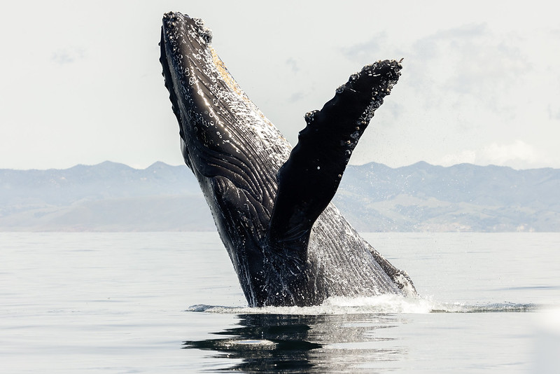
AI’s influence on travel planning continues to be something to watch as there will likely be both opportunities and disappointments. Utilizing AI in travel searches often generates canned responses that disappoint travelers seeking unique experiences. When asking about “4 days in Los Angeles,” users may receive only traditional recommendations requiring extra effort to discover specialized options. This challenges destinations offering distinctive experiences that don’t appear in generic AI results. The key question becomes how destinations can leverage smarter AI to deliver meaningful travel experiences, support stewardship plus satisfy visitors’ craving for authenticity.
Luxury Travel: Redefining the Experience
The luxury travel market is changing the traditional notions of what luxury means. It doesn’t have to be ostentatious. Rather, today’s luxury travelers seek authentic experiences that create lasting memories. They’re drawn to exclusivity and luxury without showing off. Interestingly, luxury doesn’t need to be present the whole trip. Travelers might stay in luxury accommodations, but spend their days engaging in many of the same types of experiences as more budget-focused travelers. Wellness travel also continues to increase amongst luxury travelers, with many seeking opportunities to digitally detox. And sustainability is becoming a key factor for luxury travelers who are increasingly making values-based choices with higher expectations for brand responsibility.
Sustainability Takes Center Stage
Sustainable travel continues to be in the spotlight for travelers, however, much research has emerged that what people say vs. what they do are very different. Consumers say they are willing to switch from brands that neglect the environment, and 55% relying on brands to raise awareness of environmental issues, with 70% valuing sustainability more than they did two years ago and 76% expecting brands to reduce their carbon footprint, but few participate in stewardship activities while traveling.
Many are suggesting that success should be measured not just by visitor numbers but by positive impact on local communities and places. The future of destination marketing is shifting from promotion to protection, moving from a growth-focused mindset to a sustainability-driven approach. Destinations must find the balance between local needs, business priorities and brand perception, something this organization has been mindful of for over a decade.
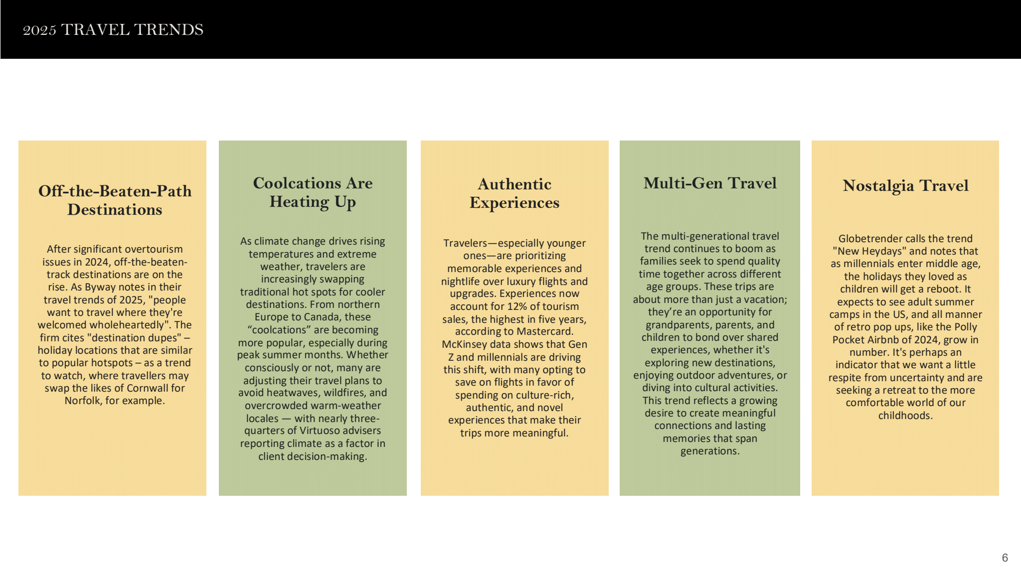

Key Objectives & Strategies
Highway 1 Road Trip has outlined three organizational objectives in the 23-27 strategic plan, including key indicators and strategies:
OBJECTIVE 1 – ACCELERATE STRATEGIC PARTNERSHIPS
Strategies
- Foster a deeper integration with Visit SLO CAL planning and programs to ensure Highway 1 voice and visibility
- Develop deeper connections with DMOs and attractions in all Highway 1 communities to collaboratively grow awareness of Highway 1 in SLO CAL
- Bolster CBID/LFA strategic connections through expansion of LFA imperatives and increasing opportunities to connect and collaborate
- Explore strategic partnerships with external businesses and organizations to increase awareness of our stretch of Highway 1
OBJECTIVE 2 – EXPAND EDUCATION AND COMMUNITY CONNECTION
Strategies
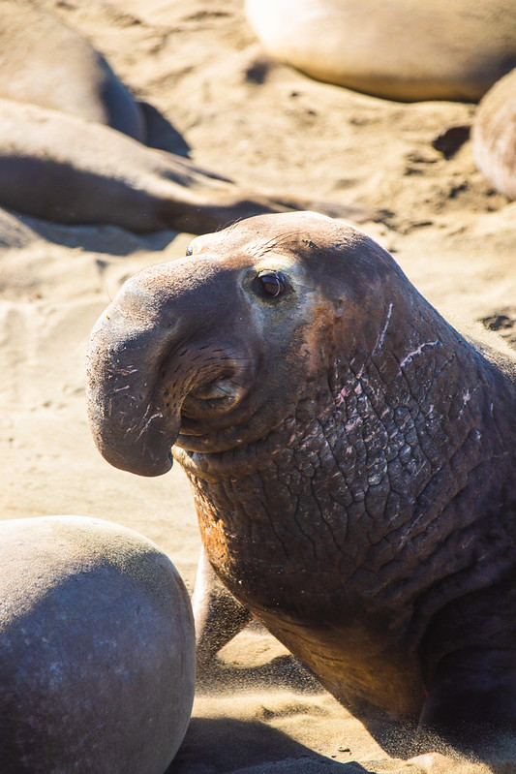
- Identify and elevate best practices and LFA community engagement and share to all LFAs
- Engage CBID Board members in attending LFA Board meetings and institute regular connection between board chairs
- Support integration of Visit SLO CAL programs into our communities
- Multiply opportunities for LFA communities to work together and cross-promote
- Engage Highway 1’s broad constituency to educate, inform, gather feedback, and demonstrate value
OBJECTIVE 3 – DRIVE MEASURABLE RESULTS
Strategies
- Leverage new brand to maximize awareness and to improve shoulder and off-season visitation
- Partner with Visit SLO CAL programs to drive visitation within our communities
- Continue to invest in development and sharing of high-value digital assets
- Investigate opportunities to leverage the Highway 1 asset as a sustainable and inclusive road trip experience

Destination Partners
Highway 1 Road Trip partners with organizations via Visit SLO CAL to impact programs, and through Visit California and Brand USA to showcase the coastal communities to a larger audience. Key to Highway 1 Road Trip’s main focus is the specific partnership with Visit SLO CAL, other area destinations like Morro Bay and Paso Robles, and specifically with the local fund areas of Ragged Point, San Simeon, Cambria, Cayucos, Los Osos|Baywood, Avila Beach, Edna Valley|AG Valley, and Oceano|Nipomo.

Initiatives for 2025 | 2026 Fiscal Year
Looking Ahead - Maintaining Strength Through Brand Integration and Partnerships
As we look to the future, we will continue to support successful programs, test new ideas and technologies, and grow awareness of the Highway 1 Road Trip brand by supporting our new creative direction, focusing on additional video production, developing a deeper understanding of our database, continuing to integrate Travel for Good messaging, and testing new technology as opportunities arise. In addition, we will complete the transition to a new non-profit entity to help streamline the organization and drive efficiencies and flexibility.
We also look forward to the opportunity to work with Visit California, Visit SLOCAL and Visit Monterey to announce the reopening of Highway 1.
As a result, several key strategies are in play. They include:

- Detour Destination: Collaboration with Visit California and Visit SLO CAL with the 2026 World Cup Soccer event and the 2028 Olympics both taking place in Los Angeles, our area becomes an opportunity for travelers to detour when attending these large events. Partnership opportunities with visit SLO CAL and regional DMOs have potential as does the Visit California road trip campaign “Playful Journeys” where our area could be featured as something not to miss.
- Just Coast Branding Just Coasts: With a new brand in place, we see an opportunity to continue to further explore an enhanced video strategy to further tell our story, along with refreshing the website copy with the updated brand voice – particularly related to our Travel for Good programming.
- Paid Media – Integrate and Optimize Partnerships to Drive Efficiencies: With a goal to lower social media management costs, we are looking to consolidate with one partner as well as testing bidding parameters, refine targeting, optimize creative, and test add a larger organic footprint in Pinterest that may lead to paid media opportunities.
- Email - Steady as we Go: Our email program is strong, and our database continues to grow through the use of several maps as lead generation tools. We will work toward gaining more insights and testing various approaches as we move through the coming year.

- Potential Expansion of LFA programs: Utilizing the strength of Highway 1 Road Trip efforts, we continue to explore options for the local areas to participate. One example is a potential test with Sojern who has developed a program that utilizes search data for flights into San Luis Obispo. We have an opportunity to create a program that allows the LFAs, Sojern, and local hotels and attractions to all co-fund an effort to drive direct bookings.
- Organic Social Media Transition: As visitors’ behavior on social media continues to change, we see an opportunity to transition our efforts to focus first on Instagram, then Facebook and creating some additional Pinterest exposure.
- PR in Person: As the publishing world continues to consolidate, the H1RT public relations team will be continuing a focus on themed FAMS to get writers to visit and ensure coverage with major publications featuring experiences in line with current travel trends.
- Reopening of Highway 1: With a constant, watchful eye toward the timing of the reopening of Highway 1, we are collaborating with Visit SLO CAL, Monterey County, Santa Barbara, Ventura, and Visit California.
Over the past several years we’ve made huge strides. Each and every member of the team has worked to drive a continuous improvement process - always looking and testing new ideas while at the same time, improving on the tried and true. As we look to the future, we will continue to support successful programs, test new ideas and technologies, and grow awareness of the Highway 1 Road Trip brand.

Continued Branding Integration
.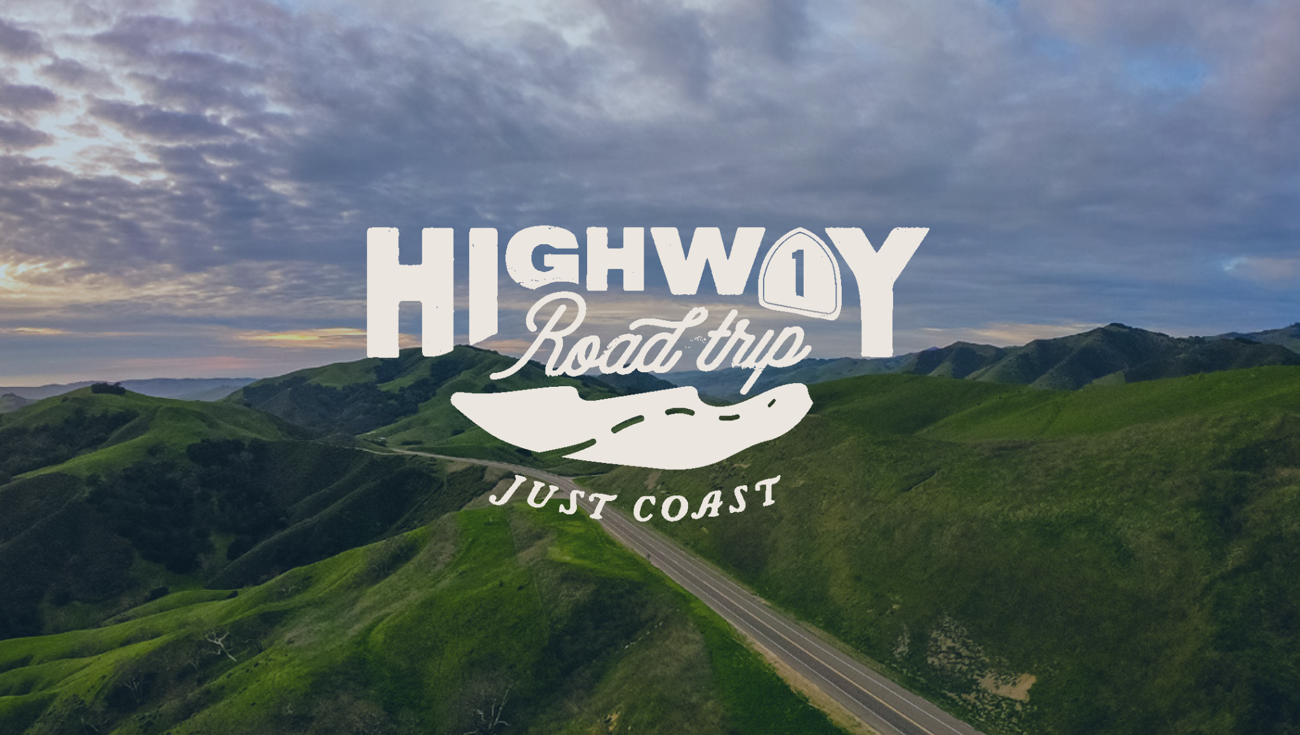
Just Coast Just Coasts: With fresh, bold concepts that resonate with our audience, we will further define a distinctive branding direction that captivates our target market. Focused as a springboard for creativity within our team, everyone will continue to add their inspiration that further tells our most authentic story. View the full Brand Guide here.
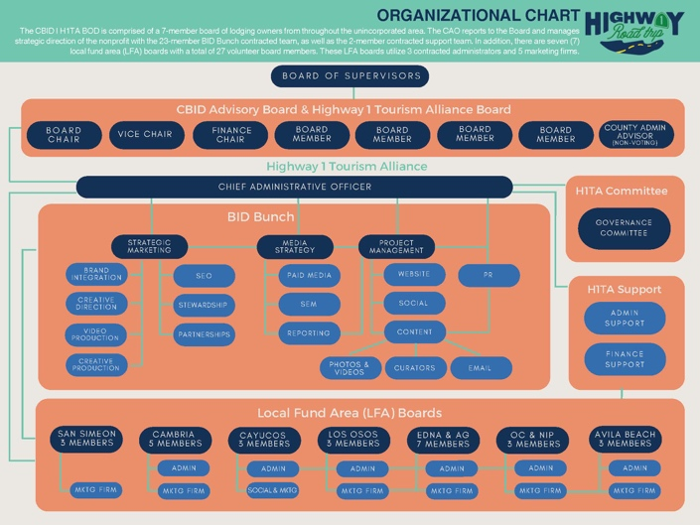
Our BID Bunch is our most valuable asset. With 23 professional contractors, it has allowed our marketing organization to drive measurable results that support top-notch TOT performance when compared to our DMO counterparts.

BID Bunch Tactical Project Focus

Strategic Marketing – Lori Keller
Responsible for developing and overseeing the execution of a comprehensive marketing plan that aligns with the organization's overall goals.
- Market Research and Analysis
  - Staying informed about industry trends and consumer behavior to gather insights and adapt strategies accordingly.
  - Continually analyze campaign performance data to make data-driven decisions.
  - Ongoing awareness of new technologies, programs, and potential opportunities that may apply to H1RT efforts to ensure a continuous improvement culture.
  - Manage brand lift studies and other surveys/measurement tools as opportunities arise.
- Team Leadership
  - Co-lead and manage the strategic integration of all team efforts including the LFA Imperatives
  - Oversee specific contractors to ensure continued progress (Brad/Vingage, Lori Ritchey, Ann’s Orange 22 team, Katie)
  - Continue partnership efforts with Visit SLO CAL (serving on the marketing committee).
- Brand Management and Program Execution
  - Manage the creative development process with Sunshine & Bourbon to deliver brand assets to paid media outlets that is reflective of Highway 1 Road Trip’s Just Coast brand.
  - Oversee paid media strategy team and lead the execution of paid media efforts ensuring a continued test and learn strategy is in place to attain growth of critical KPIs.
  - Year-end reporting and board communication as needed.
- Partnerships
- Continue to look for strategic partnership opportunities related to the LFAs, Visit SLO CAL, Visit California, and/or other area DMOS.

Content Marketing – Lori Ritchey with content curators Jaime Lewis and Hayley Cain

Manage the overarching content calendar, integrating content across all channels/disciplines: website (authority page, blog, photos, video, CrowdRiff), lead generation maps, email, organic social media, paid media, paid social, and public relations.
- Content Audit and Content Calendar Management:
  - Creation and management of fiscal year content plan.
- Content Creation and Adaptation:
  - Work with Content Writers to create new or adapt existing content.
- Social Media Strategy:
  - Oversee social media strategy in keeping with overarching strategy developed last year.
- Email Marketing:
  - Work with Kempler to continue to inform and engage new and existing subscribers about reasons to visit.
  - Delve into subscriber behavior to better understand what types of content is the most engaging.
- Content Distribution Plan:
  - Ensure branding continues to reach the intended audience across all relevant channels.
  - Schedule content releases to maintain a steady stream of brand messaging to the market.
  - Paid Media Campaign: Develop campaign toolkit for distribution.
- Manage Blog Strategy:
  - Identify strategy for lifting blog rankings and exposure.
  - Content ideation for blog topics.
  - Provide blog outline for writer to follow.
- Monthly Management and Collaboration with the following BID Bunch Members: Jeff Pedigo (Website), Jaime Lewis & Hayley Cain (Content Writers), TJA/Claudia Jensen (Social Media), and Kempler (Email Marketing) to manage priorities, projects, deliverables, deadlines, provide proactive ideas and processes.
- Monthly Reporting Recap: Gather and consolidate reporting monthly from contractors to create a comprehensive report for the Advisory Board.

Creative Advertising Campaign Concept & Development – Sunshine & Bourbon
With brand strategy oversight, manage the creative development that is reflective of California Highway 1 Road Trip’s Just Coast brand:
- Ongoing creative direction to facilitate brand standards throughout all elements of the integrated marketing campaigns, including the production of creative assets for paid media.
- Video concepting and production focused on YouTube and social media assets, along with website header videos to continue to tell both the brand story and provide content for common traveler searches.
- Sunshine & Bourbon also will work with the team to rewrite Travel for Good content that is more visitors facing, focusing on the benefits of being a sustainable traveler and a good steward of our area.

Email Marketing – Kempler Group
Create effective email campaigns and increase engagement. Focus this year will be on continuing to build user preferences (audience buckets) and using dynamic content to provide relevant content. With the new Highway 1 Road Trip brand fully integrated into the email program, there exists and opportunity to test which types of components and content resonate best with subscribers.
- Continue delivering engaging and content rich newsletters to the H1RT’s audience. Implement email marketing strategies to maximize exposure and engagement.
- Engagement - Use of preferences and dynamic content to be more engaging. Survey emails to gather preferences and customer insight.
- Deploy messaging to subscribers regularly as well as track and analyze the performance of each email campaign to provide detailed reports on the open and click-through rates.

Social Media: Claudia Jensen, TJA
Enhance brand visibility and engagement through strategic organic social media management and content creation across platforms.
- Develop comprehensive content for Facebook (FB) and Instagram (IG) focusing on consistent posting schedules and varied content types to maintain audience interest. Cadence will be 10 to 12 posts per month.
  - Update older stories to reflect new content and best practices.
  - Develop visually appealing Pins for Pinterest to drive traffic and increase brand visibility within relevant communities.
  - Use new content developed by the H1RT team as pins such as blogs and major PR features.
  - Identify opportunities for user-generated content and encourage user participation through photo sharing and tagging.
  - Repurpose existing Instagram Reels content for TikTok to expand reach and tap into a younger demographic. Tailor content to suit TikTok's platform dynamics and trends while maintaining brand consistency.
- Implement strategies to increase follower engagement focusing on what is working based on the current algorithm.
- Monitor and respond to audience comments, messages, and mentions promptly to foster a sense of community and enhance brand loyalty.
- Fully utilize CrowdRiff:
  - Continuously source high-quality user-generated images through CrowdRiff to showcase authentic experiences and local attractions.
  - Curate and manage CrowdRiff galleries to highlight diverse content and optimize visual storytelling.
  - Stay up to date on CrowdRiff updates and communicate best practices to the LFAs.
  - Produce engaging Localhood Stories that showcase unique experiences and new content created by the H1RT team to promote destination awareness.
- Reporting: Generate regular performance reports detailing key metrics such as engagement rate, reach, follower growth, and content effectiveness. Analyze data to identify trends, insights, and areas for improvement, and adjust strategies accordingly to manage to KPIs:
  - Increase in organic reach and engagement across social media platforms.
  - Growth in follower base and community engagement metrics (likes, comments, shares, etc.).
  - Improvement in content performance indicators such as click-through rate and conversion rate.
  - Enhanced brand sentiment and positive feedback from the community.

Search Engine Optimization – Brad Rubin and Vingage team (Lucas and Daina)

Organic search is an important component to our overall success and has been an ongoing focus. A comprehensive workbook will be created for the next year with two SEO focuses - new specifications and proposed spec updates.
The new specifications task consists of ideas for new content where H1RT can capture additional search traffic. This also includes common searches for video, specifically YouTube optimization. The team will collaboratively work to prioritize the content for development.

Website – Jeff Pedigo
Several website enhancements are planned for the coming year, including:
-Google Translation Widget: Implement a site-wide Google Translate widget to improve accessibility for international visitors.
-Map View for Tiles: Add a "Map View" option wherever tiles appear. This feature would allow users to switch from tile view to an interactive map with pinpoints for each tile.
-Homepage Design Refresh (Video Header): Collaborate on a visual update to the upper section of the homepage, including the video header.
-Neighboring Communities Integration: Partner with Brad to develop a recommendation and execute a solution for better integrating nearby destinations (e.g., Morro Bay, San Luis Obispo, Pismo Beach). The goal is to create a cohesive landing page or content hub that ties these areas into the Highway 1 narrative.
-Mailchimp Automation & Web Form Integration: Partner with Kempler to migrate existing email automations to the latest Mailchimp technology, allowing users to re-request assets (like maps) more than once.

Stewardship Travel for Good – Katie Sturtevant
This award-winning program continues to focus on evolving a newsworthy platform to bring media to our area.
- Continue integrating approachable travel for good content in all of our marketing efforts.
  - Include stewardship/sustainable efforts and experiences during FAM and other media visits to encourage writers to use our existing stewardship content like the wildlife viewing tips, Back to Nature Tours, etc.
  - Integration with Local Fund Areas and Visit SLO CAL’s efforts in the sustainability space.
  - Work with the Sunshine & Bourbon team as necessary to transition Travel for Good content into a voice that speaks to communicate the advantage of using our tips and tools to visitors.

Public Relations – Kirstin Koszorus with Katie Sturtevant
Outreach continues to focus on targeted outlets with the following goals:
- At least 50% of online articles secured include a direct link to Highway1RoadTrip.com
- At least 45% of all coverage secured appear in a target outlet
- At least 5 articles will include Stewardship Travel for Good meaningful tips for travelers in the story
- Secure 88-100 placements

Media Hosting and Media Missions
- 1 Group FAM’s (3-5 Media/FAM)
  - Partnership FAM with Visit Santa Maria Valley
- 8 Individual Media Visits
- Travel Classics (October 2025)
- IMM (January 2026 in NYC)
- Visit SLO CAL Media Event (Los Angeles)

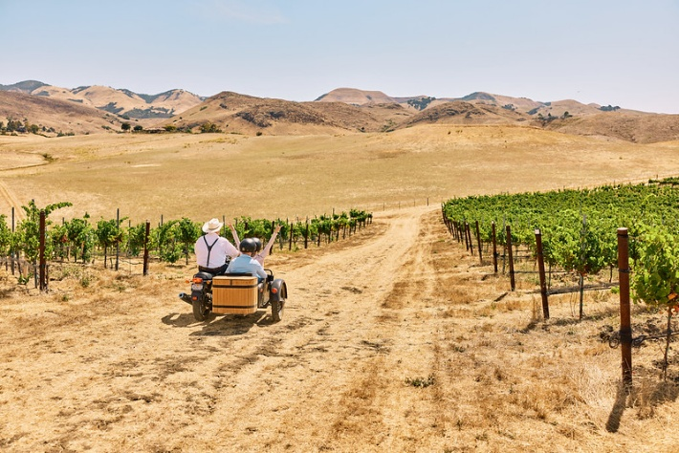
Paid Media Strategy/Execution – Ann Balboa and Orange 22 team (Dave, Alicia, Mike)
In 2024-25, paid media experienced remarkable growth in traffic, conversions, CRM, and cost efficiencies. 2025-26 paid media planning will build on our continuous improvement strategy using:

- Consolidation of social media vendors to drive efficiencies.
- Expansion of First-Party Data integrations for targeted advertising, emphasizing CBID's database for lookalike programming and making database growth our top KPI. Additionally, we’ll explore effective retargeting strategies based on map downloads.
- Utilization of automation and AI for streamlined data collection, reporting, and analysis.
- Exploration of audience-centric targeting avenues such as Google Audiences and cohorts.
- Data-driven ad targeting and personalization for tailored messaging to relevant audience segments.
- Further expansion of video content, including a broadened focus on utilizing YouTube.

Campaign Seasonality
- Fall: Just Coast branding with a coastal experiences focus (hiking/hidden secrets)
- Winter: Just Coast branding with a wildlife focus (Jan/Feb)
- Spring Just Coast branding with a beach | wildflower | green hills focus
Targeting
- Geographical:
  - San Francisco-Oak-San Jose (DMA)
  - Los Angeles (DMA)
  - Fresno Visalia
  - San Diego
  - Exclude: San Luis Obispo County
- Demographics:
  - Ages 35+, $175k HHI+, Gender: All

- Custom Audiences:
  - Retargeting & Lookalikes
    - Email list
    - Map downloads
    - Website visitors
    - Facebook engagement
- Interests/Behaviors
  - Beach Goers/Beach Lovers
  - Road Trip, Road Trippers
  - Wine lovers
  - Swimmers & Surfers
  - Adventurers/Frequent Travelers
  - Outdoors / Outdoor enthusiast
  - Ocean lovers
  - Health and wellness seekers
  - Family
  - Wildlife /wildlife conservation / whale Watching
  - National Parks, State parks
  - Parks/Weekend Trips
  - Hiking, Hiking Trails
  - Nature
  - Travel + Leisure, Travel Enthusiasts
  - Frequent travelers
  - Nature Reserve
  - Scenic /Nature/ Landscape/ Wildlife Photography
  - Travel Bloggers
  - Vacation rental seekers
  - Empty Nesters
  - Senior Travelers
  - Retirees and seniors
Consideration Key Performance Indicators – Reported Monthly
- 45% = Map Downloads / CPL
- 27% = engagement/ CPE
- 27%= Time on site (4+ Pages)
Note: Final media plan will be presented in June 2025.

Reopening of Highway 1
As we look to the day when Highway 1 will be fully open to explore, H1RT is working with Visit California, Visit SLOCAL, Cambria, and Visit Monterey, along with San Simeon, Hearst Castle and Morro Bay, to develop programs and messaging that can be deployed when the time is right.

Measuring Our Success
When considering our key performance indicators, we focus on engagement/time on site and map downloads. We also developed a two-pronged survey of our database based upon whether the potential visitor had downloaded a map to get an understanding for the benefit of travel intent among those who completed a download. Among those who downloaded a map, nearly 92 percent said it encouraged them to take a road trip on Highway 1 and 82% said it helped them to plan their travel. We continue to look for ways to gather data to assist in making informed decisions.

Brand Lift Study
We conducted an initial brand lift study in April 2024 to establish a baseline, followed by a second study in April 2025 to evaluate the impact of our new “Just Coast” creative. The 2025 campaign delivered our first statistically valid brand lift on YouTube, showing a +2.15% lift in ad recall and over 17,000 lifted users at a highly efficient $0.52 cost per lifted user. Results confirmed that mobile-first vertical assets (:15s, :30s) are most effective for upper-funnel awareness, while longer-form content performs better for retargeting.

Muck Rack Public Relations
Highway 1 Road Trip has switched to using the media monitoring service Muck Rack to create more robust reports for our PR accomplishments. Not only does the service track coverage of the region on an ongoing basis, which assists in alerting us when articles we have worked on about the area have come out, it also provides details on the coverage such as unique monthly visitors, sentiment of the article, social coverage of the article, clicks to Highway1RoadTrip.com and more. MuckRack is also now connecting to our Goggle Analytics and provides direct traffic from stories so we can better connect upticks on our website with published stories.

A Living Document
This overall plan provides the BID Bunch with a working direction for the coming year. It is a living document, meaning that as things change, pieces of the plan may change to best adapt to new conditions. That has shown to be particularly important over the past few years. Each of the BID Bunch members have specific tactics outlined in their agreements that are measured and adjusted regularly to adapt to new challenges as well as new opportunities.
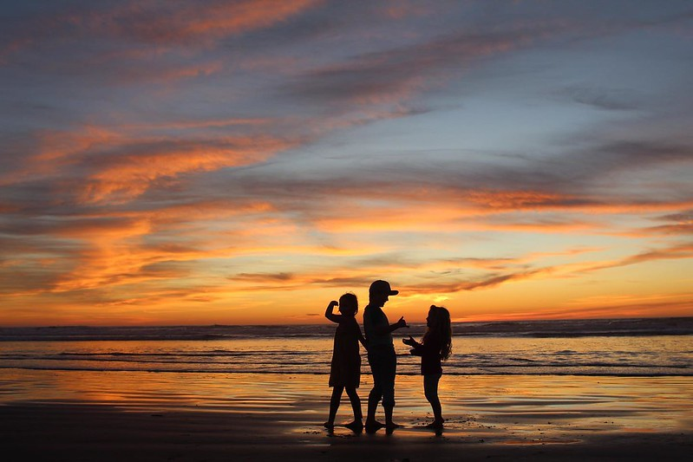

Strategic Plan 2023-2027
